|  |  |
| --- | --- |
| **EXPT NO: 13**  **DATE:** | **MINIPROJECT : BMI-CALCULATOR** |

**AIM:**

To develop a mobile application called “BMI-Calculator”.

**ABOUT THIS APP:**

BMI-Calculator is a fitness tool to measure body mass index for our daily healthy life. BMI-Calculator is the app which allows the user to calculate their Body Mass Index and it also provides the accurate measurement based on the weight and height provided by the user.

**APPLICATION INFORMATION:**

* + Version: “1.0”
  + Updated on: 10.12.2021
  + App-size: 9.02 mb
  + App-permission: no permission required
  + This app is compatible for both IOS and android version.

**FEATURES OF THIS APP:**

* Free to use
* No internet connection is required to calculate the index
* Imperial and metric measurement units are supported

**USE OF BMI CALCULATOR:**

* BMI is a reliable indicator of body fatness for most people
* It is used to screen for weight categories that may lead to health problem

**SOURCE CODE:**

**activity_main.xml:**

<?xml version="1.0" encoding="utf-8"?>

<LinearLayout xmlns:android="http://schemas.android.com/apk/res/android"

xmlns:app="http://schemas.android.com/apk/res-auto"

xmlns:tools="http://schemas.android.com/tools"

android:layout_width="match_parent"

android:layout_height="match_parent"

android:orientation="vertical"

tools:context=".MainActivity">

<TextView

android:layout_width="wrap_content"

android:layout_height="wrap_content"

android:layout_gravity="center_horizontal"

android:text="Weight"

android:textSize="30dp"

android:layout_marginTop="80dp"/>

<EditText

android:id="@+id/weight"

android:layout_width="wrap_content"

android:layout_height="wrap_content"

android:layout_gravity="center_horizontal"

android:ems="6"

android:textAlignment="center"/>

<TextView

android:layout_width="wrap_content"

android:layout_height="wrap_content"

android:layout_gravity="center_horizontal"

android:text="Height"

android:textSize="30dp"

android:layout_marginTop="30dp"/>

<EditText

android:id="@+id/height"

android:layout_width="wrap_content"

android:layout_height="wrap_content"

android:layout_gravity="center_horizontal"

android:ems="6"

android:textAlignment="center"/>

<Button

android:id="@+id/calculate_button"

android:layout_width="wrap_content"

android:layout_height="wrap_content"

android:layout_gravity="center_horizontal"

android:text="Calculate BMI"

android:layout_marginTop="30dp"

android:onClick="calculateBMI"/>

<TextView

android:id="@+id/result"

android:layout_width="wrap_content"

android:layout_height="wrap_content"

android:layout_gravity="center"

android:text="Result"

android:textSize="30dp"

android:layout_marginTop="20dp"/>

**MainActivity.java:**

package com.example.bmi_calculation;

import androidx.appcompat.app.AppCompatActivity;

import android.os.Bundle;

import android.view.View;

import android.widget.EditText;

import android.widget.TextView;

public class MainActivity extends AppCompatActivity {

EditText weight,height;

TextView resulttext;

String calculation,BMIresult;

@Override

protected void onCreate(Bundle savedInstanceState) {

super.onCreate(savedInstanceState);

setContentView(R.layout.activity_main);

weight = findViewById(R.id.weight);

height = findViewById(R.id.height);

resulttext = findViewById(R.id.result);

}

public void calculateBMI(View view) {

String S1=weight.getText().toString();

String S2=height.getText().toString();

float weightValue = Float.parseFloat(S1);

float heightValue = Float.parseFloat(S2)/100;

float bmi = weightValue/(heightValue * heightValue);

if(bmi<16){

BMIresult="Severely Under Weight";

}else if(bmi<18.5){

BMIresult="Under Weight";

}else if(bmi>=18.5&&bmi<=24.9){

BMIresult="Normal Weight";

}else if(bmi>=25&&bmi<=29.9){

BMIresult="OverWeight";

}else{

BMIresult="Obese";

}

calculation="Result:\n\n"+bmi+"\n"+BMIresult;

resulttext.setText(calculation);

}

}

**OUTPUT:**

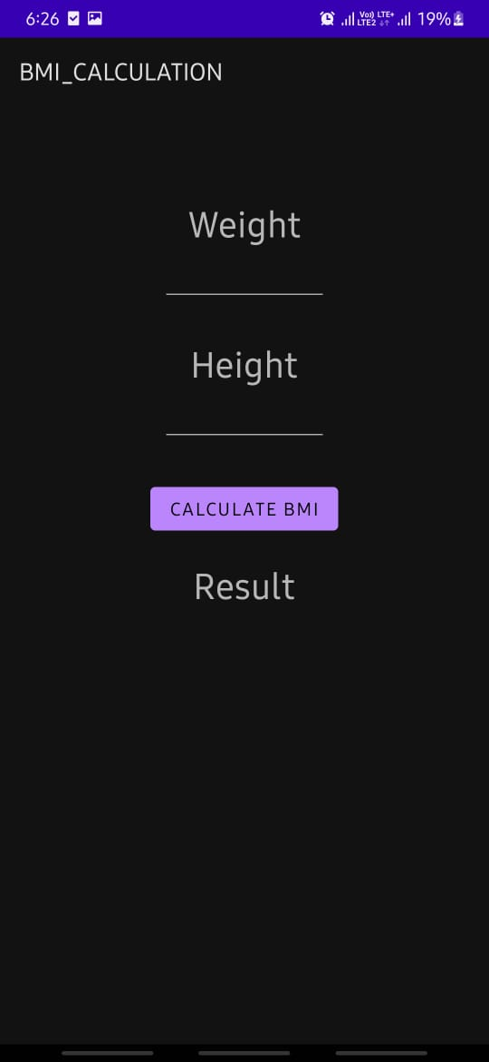 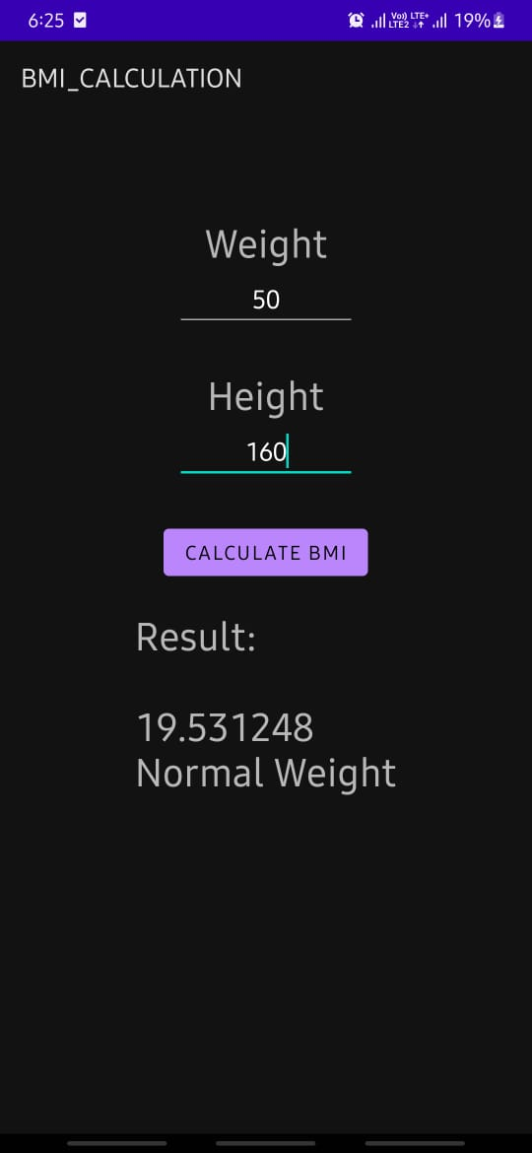

**RESULT:**

Thus the mobile application called “BMI-Calculator” is been developed successfully.